**7th Grade Texas History Syllabus – Angle**

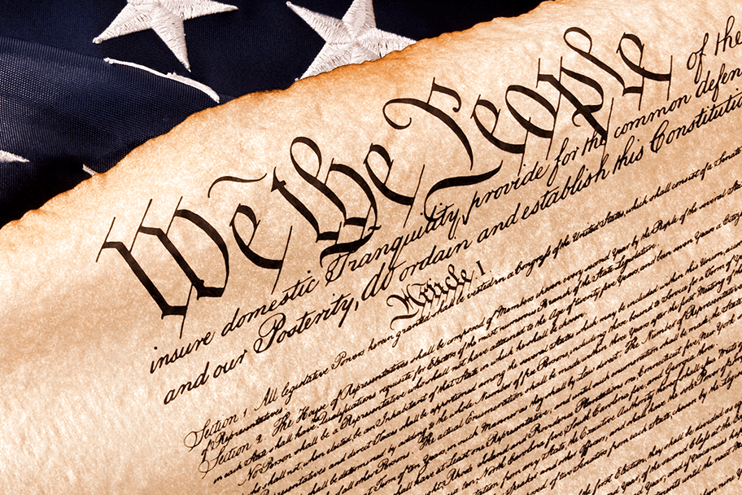

**2024-2025**

**Units/Eras of Texas History:**

Grading Period 1

Unit 1: Early Texas and It’s People

Unit 2: Spanish Colonial Era

Grading Period 2

Unit 3: Mexican National Era

Unit 4: Texas Revolution

Unit 5: Texas Republic, Statehood, and Government

Grading Period 3

Unit 5: Texas Republic, Statehood, and Government

Unit 6: Civil War and Reconstruction

Grading Period 4

Unit 7: Cotton, Cattle, and Railroads

Unit 8: 20th Century Texas

Unit 9: Texas Today

**Supplies:**

**REQUIRED** **DAILY:**

* Composition Notebook
* Planner
* Computer with charger
* pencils, lead, erasers, hand sharpener
* notebook paper
* positive attitude

**Donations (optional)**: Kleenex, tape, pencils, or any other donations are gratefully accepted

**Tutorials:** Tuesday 8:25-8:50 a.m. (Pass required)

**Contact Information:**

Email: [angela.angle@fortbendisd.gov](mailto:angela.angle@fortbendisd.gov)

Classroom Voicemail: 281-634-3000

Google Voice text: 832-844-2430 (parents/guardians only)

Schoology Messages (students)

Talking Points (parents and students)

**Conference Time**: F2F or virtual by appointment only please. If you do not schedule ahead of time, I may be unavailable. Thursday and Friday- 2:10-3:00

**Late Work:**

1 day late - 5 points

2 days late -10 points

3 days late -15 points (more than 3 days late is at teacher discretion)

*4 days late – 30 points

*5 days late – 50 points

* work will be accepted up to five days late ONLY IF student attends a tutorial session within the following week.

**Schoology:** class information, notes, reviews, and **most** class assignments and homework

**Talking Points:** receive text messages about class.

**INTERACTIVE STUDENT NOTEBOOK (ISN):** Each student will use a composition notebook, or a spiral notebook for Texas History class. ALL work for History class will be kept here including warm ups, notes, study guides, projects, etc. There should be NO LOOSE history papers in the backpack!

* Keep the ISN organized and up to date
* Bring ISN to class everyday
* ISNs may be graded at any time
* Using someone else’s ISN w/o teacher permission is considered cheating
* ISNs are ONLY for THIS class. There should not be any work for other classes in the ISN.
* If lost, students have 1 week to locate/replace. The current unit’s work/notes must be redone.

**CLASS RULES:**

**1. Stay silent and seated when Mrs. Angle is talking.**

**2. Follow directions and expectations the first time asked.**

**3. Respect and Kindness: Use polite language, volume, tone, and body language towards everyone. Respect the property and space of others. Clean up after yourself.**

**4. Phones, headphones, and electronics OFF and OUT OF SIGHT before bell finished ringing. If you want to use the charger, it must be plugged in before the bell and you cannot touch it until the end of class. If I see it, I will take it and put it in phone jail until class is over.**

**5. Keep your hands to yourself and your belongings.**

**CLASS ROUTINES AND EXPECTATIONS:**

* Advocate for yourself. Ask for the assistance and support you need to be successful.
* Absent? Ask teacher for work. Tests and projects announced ahead of time are due the day you return to class.
* Cheating – cheats you out of learning, includes asking for, taking, giving away, or copying answers. You will get a 0 and will need to resubmit the assignment in tutorials.
* Clean up: return all materials in good condition to the correct place, pick up trash in your area, check to make sure you have all your personal items.
* No Spray Zone: perfume, cologne, body sprays, etc. often cause allergic reactions. Those items should be used in the restroom/locker room, NEVER in a classroom.
* No Cussin’ Zone: profanity and obscene gestures are not allowed for any reason.
* No Snackin’ Zone: No food, drinks, snacks, gum, or candy is allowed in the classroom. Keep these items out of sight in lunch kits/backpacks.
* Stay Hydrated! Plain water in a plain water bottle is allowed and encouraged.